Collection Frameworks:
Collection framework is a set of classes and interfaces ,which is used to manipulate a group of object as an single entity.

Collection :
Collection in java is an interface which is an part of collection framework.

Collections :
Collections is the utility class in the java.which is pre defined inside “java.util” package. It is also an part of collection framework.
Collections class extends Object class as it’s Parent class.

Hierarchy of collection in java:
1.Iterable is an interface which is present inside the java.util package.
2.Collection interface implements the iterable.
3.List ,set ,Queue interface interface implements the collection.
4.Arraylist class implements the List Interface.
5.Hashset class implements the set.
6.Priority queue implements the queue.
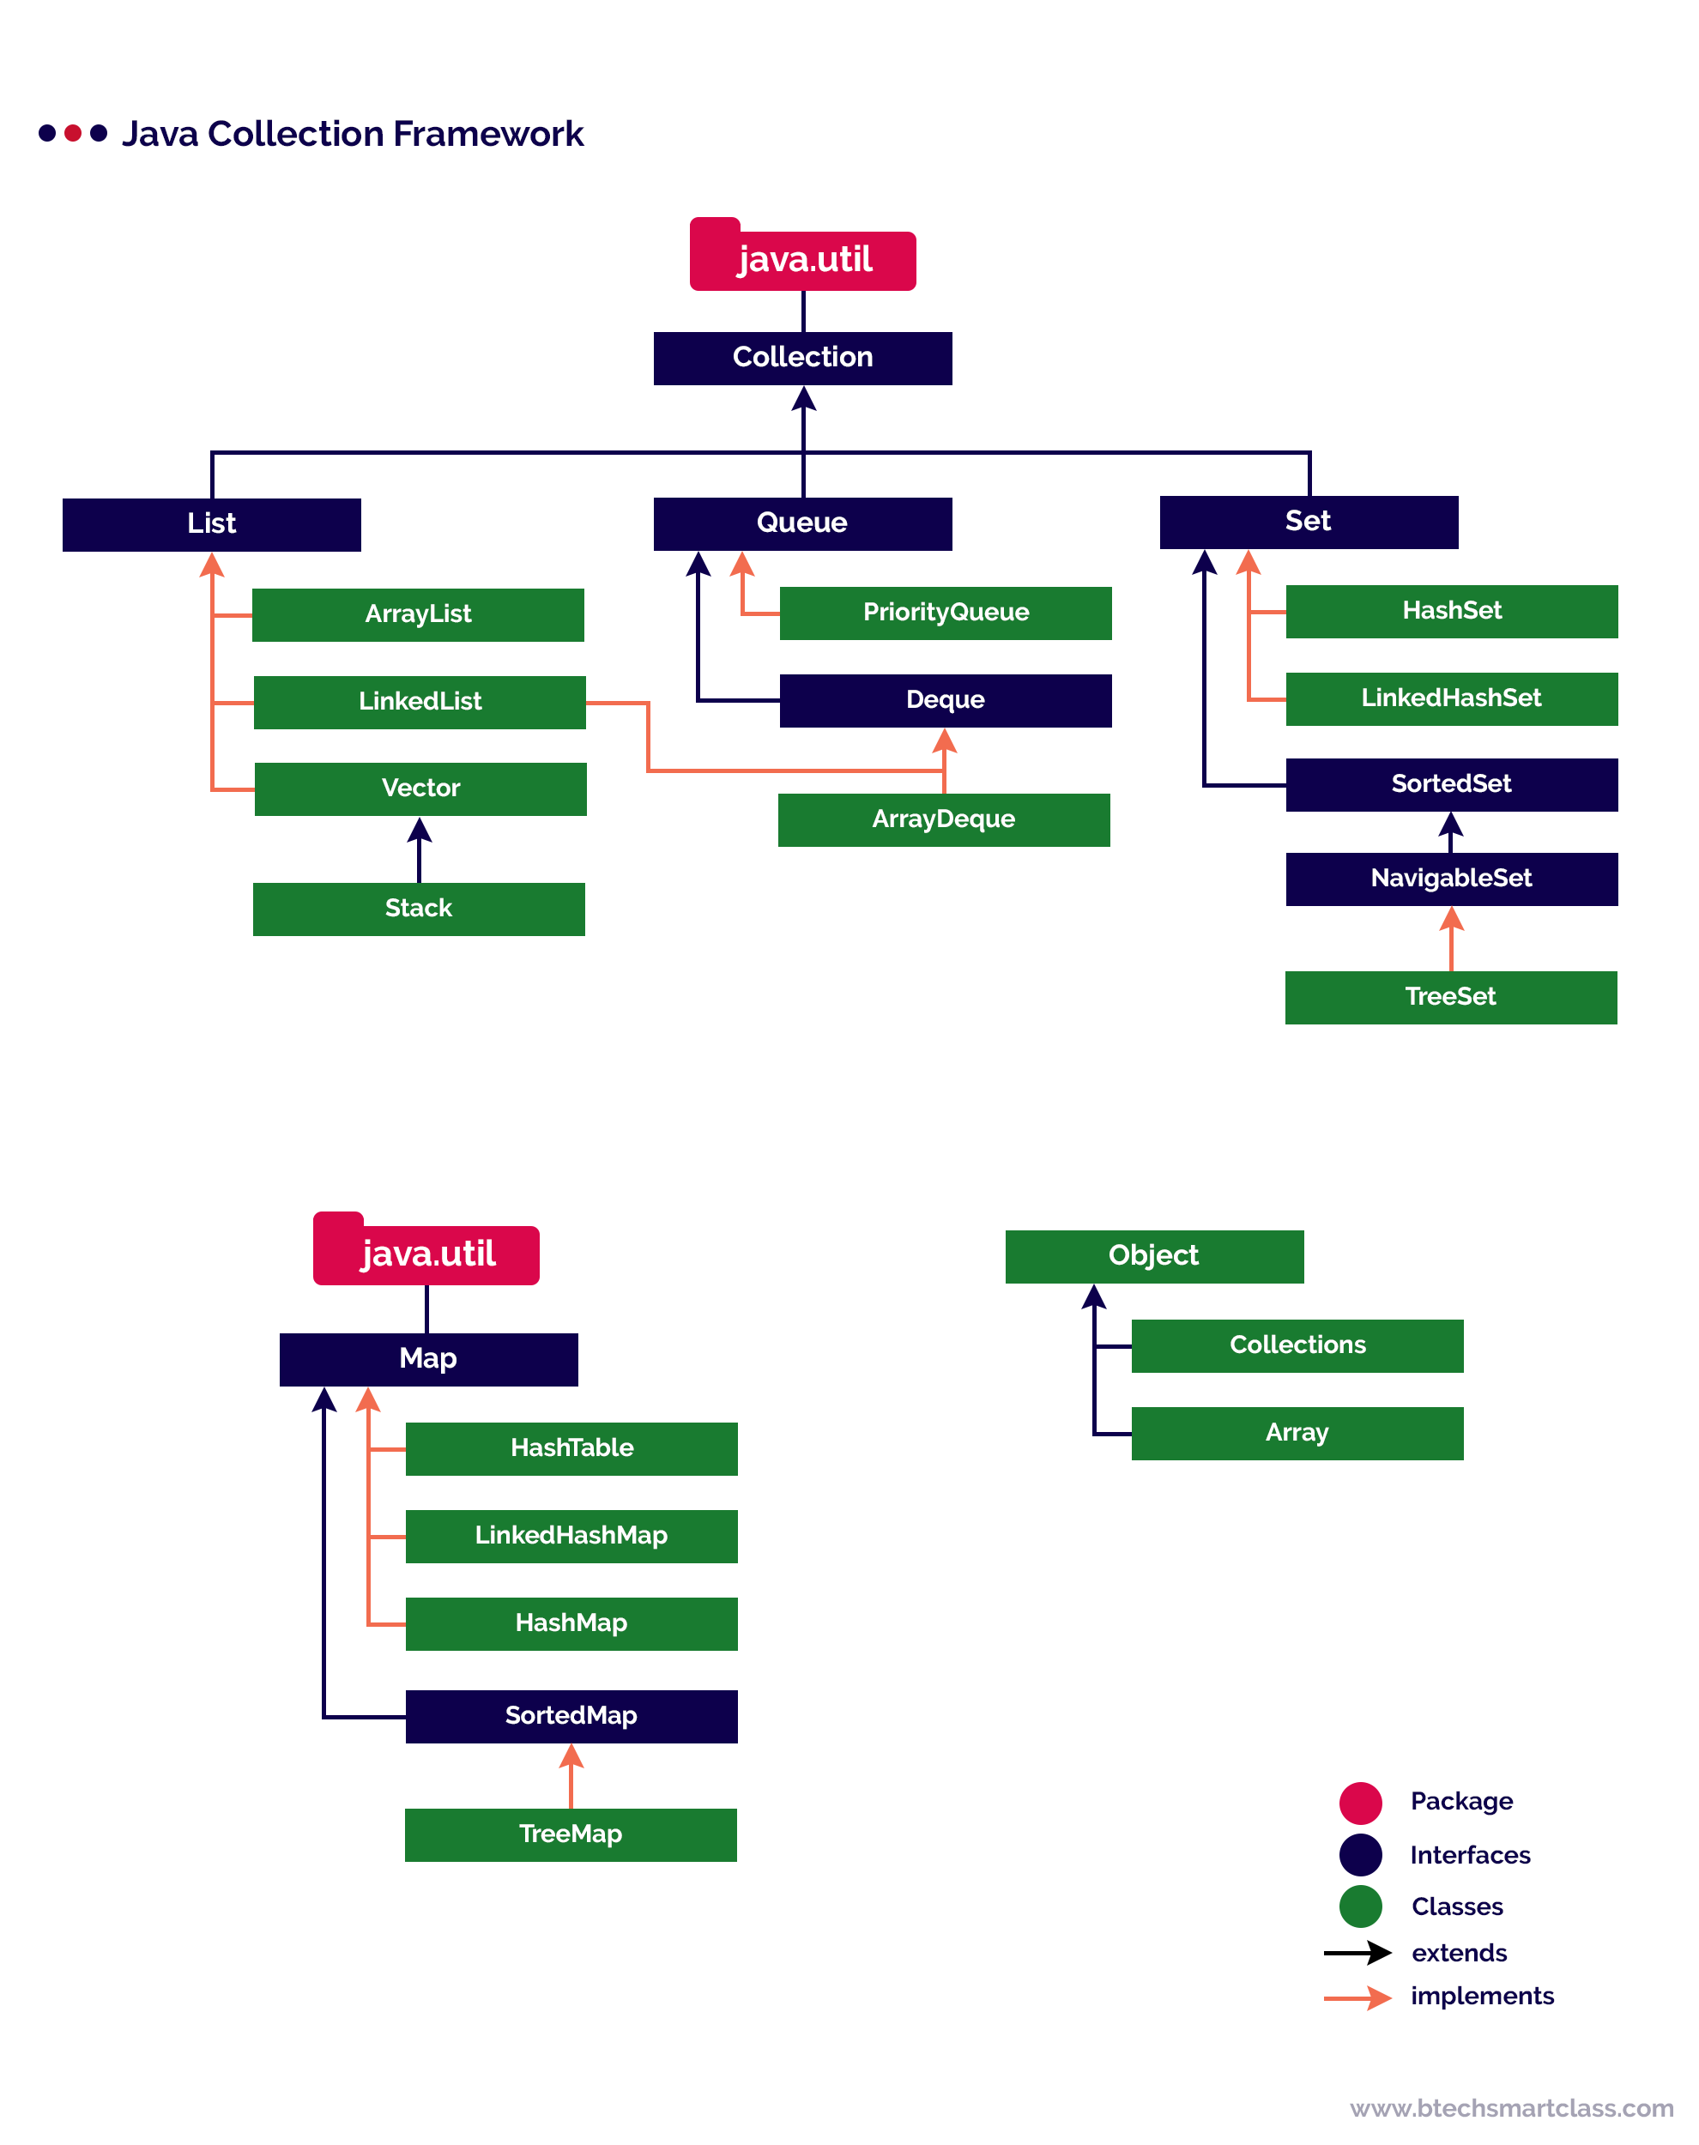
Map Interface:-
1.Map is not a part of collection hierarchy but it is an separate interface and it is an part of collection framework.
2.Collection works with single object (i.e one value) where as map works with two object pair(i.e key is an object and value is an object)
3.Entry – is an nested interface , which present inside map,to access it we Map.entry.
4.Map stores the data in key – value pair
5.Hashmap is an class which implements map interface
6.To add data we use “put” method.

Iterator Interface :
1.Iterator interface is an interface which is an part 2.collection frameworks but not a part of collection hierarchy.
3.Iterator is an method of iterator interface which is used for traversing or iterating over the elements or object of collection framework.
4.Iterator moves only forward direction.
5.Iterator interface has hasnext() and next() method.
6.hasnext() – it returns true until all objects of List,set or map are traversed.
7.Next()-it will return next object element.

List vs Set :-
List | Set
1.List contains the duplicate elements. | 1.Set does not contains duplicate elements
2.List maintain order of insertion. | 2.Set does not maintains the order of insertion.
3.List is indexed sequence,means we access elements using index. | 3.Set is not indexed sequence.
4.Classes that implements list are Arraylist and linkedlist. | 4.Classes that implements set are hashset and hashtree.

Arraylist vs Vector:-
Arraylist | Vector
1.In case of arraylist, array size is increase by 50% of current size of array. | 1.In case of vector,the size is increases by 100% of current size.means size is doubled.
2.Arraylist is updated classes. | 2.Vector is legacy classes
3.Memory optimised | 3.More memory consumption
4.Fast | 4.slow

HashSet vs Treeset :-
Hashset | Treeset
1.Object in hashset are in unsorted order. | 1.Object in treeset are in sorted order.
2.stores object of different data type | 2.stores object of same data type.

Hashmap vs Hash tree:
Hashmap | HashTree
1.can contain one key as null. | 1.null key is not allowed
2.multiple value can be null | 2.null value is not allowed

